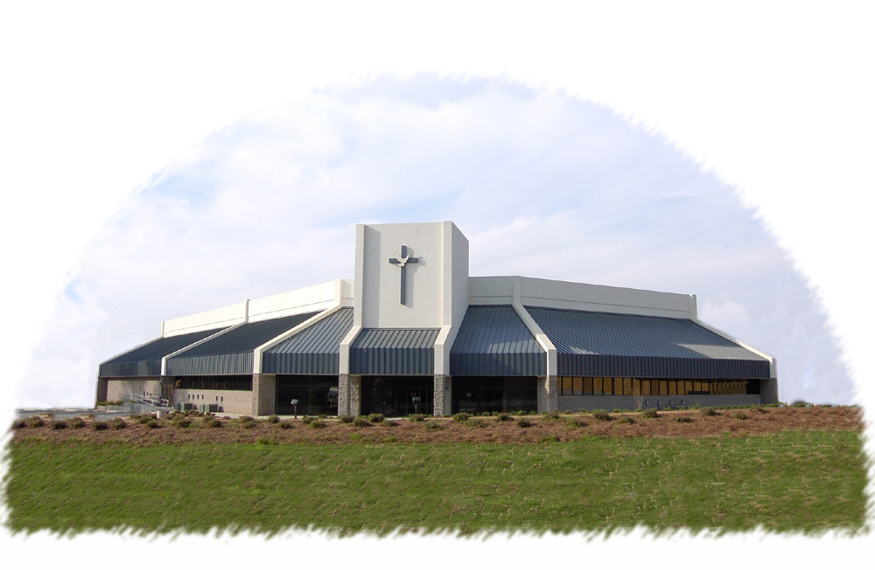
The Church
2001 Double Churches Rd
Columbus, GA 31909
www.thechurchofcolumbus.org
(706) 571-0919
Of Columbus


Nothing Shall Offend Me
2/10/1999
Wed, PM
H.L. Sheppard

